HOW TO GET BID ID
Note: For getting your Bid id if not received through SMS on mobile number , Please follow below mention steps .

Step 1. Visit MP Housing Board Link aviable on MPOnline Portal.
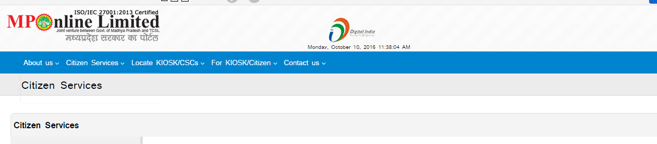
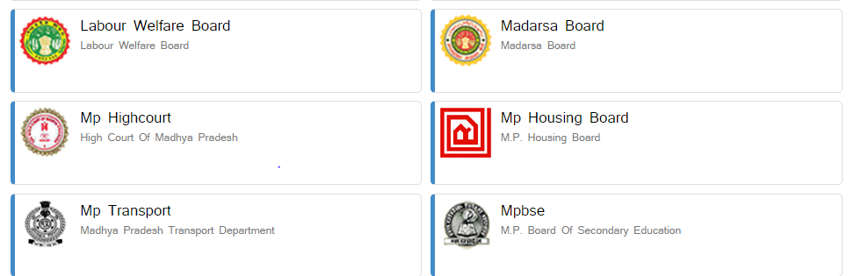
Click on MP Housing Board Option

Step 2. Please log in with your user id and password which you have received while doing your registration for Doing bookings under E-Offer in the place shown below ……
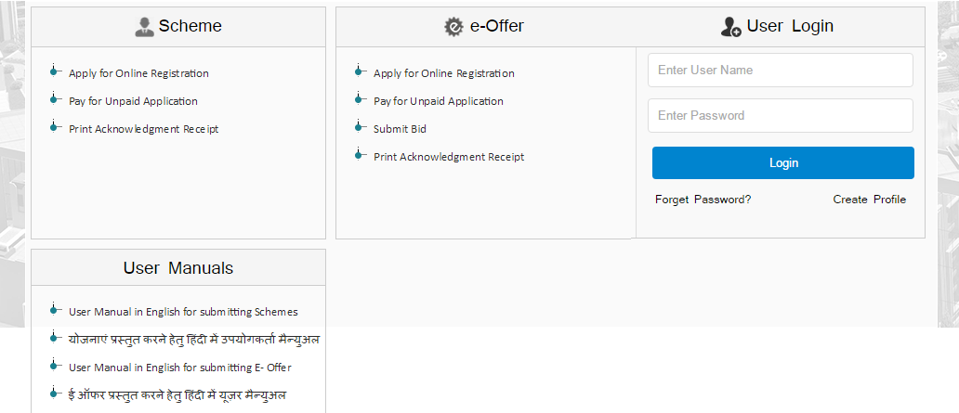

Step 3. Click on the Option given below with name ‘GET BID ID’.
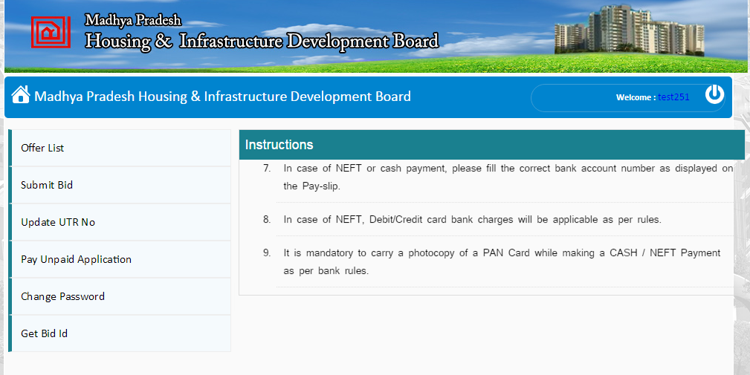
Click on Get Bid Id Option for Getting Bid id .

Step 4. A page will be Shown in which it will ask you to submit your Application no, If your amount is not received it will show message that your amount is not received and if your amount is received successfully than in the next screen you will get your Bid id.
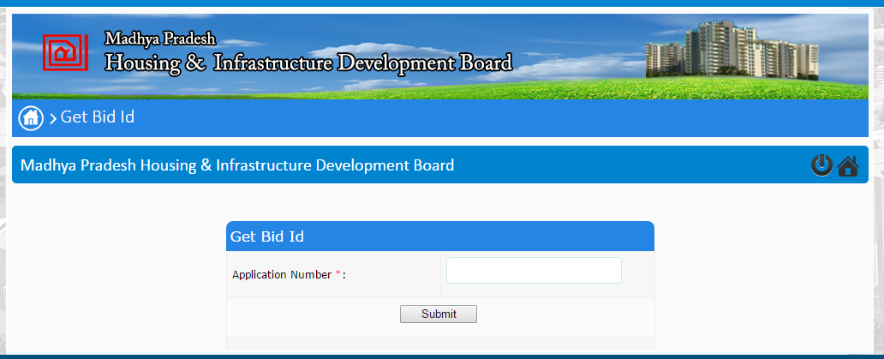
Submit your Application number.

Step 5. In the below Screen you will see your Bid id .

Bid Id – OB12324543487376483

